FR 3 Devoirs 3.2 #1 Nom ___________________________________ Classe ____
A. La pratique orale: Write a sentence about what the following people were like and what they liked to do when they were kids. Then tell a parent.
Parent Signature: ________________________
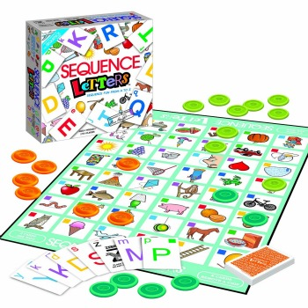
1. Paul 2.Nous

_______________________________________ _______________________________________
_______________________________________ _______________________________________
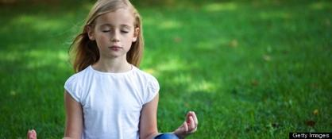
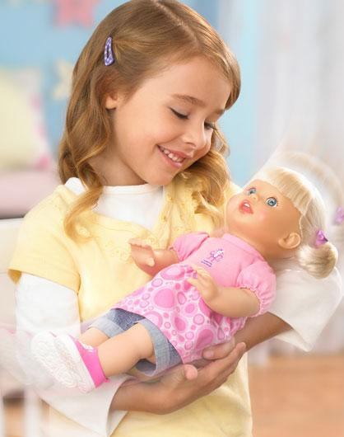
3. Mes soeurs 4.Vous

_______________________________________ _______________________________________
_______________________________________ _______________________________________
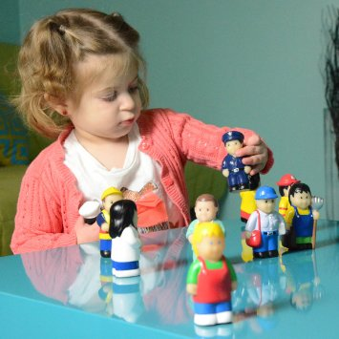
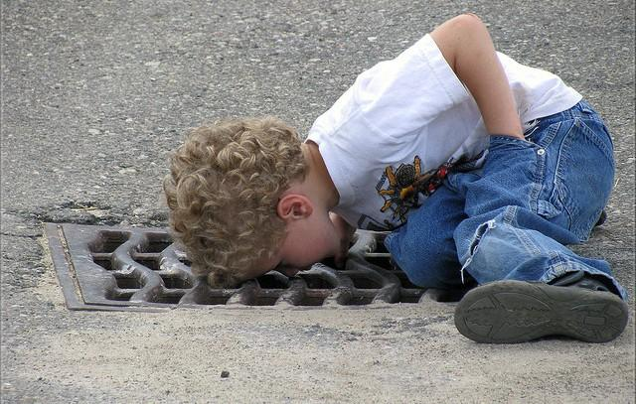

5. Je 6. Tu

_______________________________________ _______________________________________
_______________________________________ _______________________________________

B. Complete the following sentences using the passé composé to describe what these people did last weekend.

1. M. Arnaud ___________________________________________________________ (aller) au parc.

2. Jeanne ________________________________________________________ (visiter) à la banque.

3. Je ________________________________________________________ (marcher) à la campagne.
4. Thierry et Christophe ______________________________________________ (dormir) à l’hôtel.

5. Toi et tes amis __________________________________ (acheter des vêtements) au magasin.

6. Vous _________________________________________________________________ (nager) au lac.
C. Complete the following sentences using the imparfait to describe what people used to do when they were young.

1. M. Arnaud ____________________________________________________________ (aller) au parc.

2. Jeanne _________________________________________________________ (visiter) à la banque.

3. Je _________________________________________________________ (marcher) à la campagne.
4. Thierry et Christopher _______________________________________________ (dormir) à l’hôtel.

5. Toi et tes amis ___________________________________ (acheter des vêtements) au magasin.

6. Vous __________________________________________________________________ (nager) au lac.

D. Les Fautes. First underline or circle the errors in the following paragraph. (5) Then correct them. (Hint: Pay attention to the imparfait.)
Quand mon frère et moi étais petits, nous regardons la télé le samedi matin. Mes parents
dormait toujours, et donc nous étaient parfaitement libres de faire que nous voulons!

In Class Reflection:
Standard | 1  Below Level  (I don’t get it YET) | 2  Nearing Level  (I’m still working on it) | 3  At Level  (I’ve got it!) | 4  Above Level  (I can teach someone else) | My  Next Step  (What will I do outside of class to improve my proficiency in this standard?)
I can use the passé compose with avoir to write about past events.

E. For additional explanation of the For additional practice using the
imparfait scan this QR code: imparfait scan this QR code :

