FR 3 Devoirs 3.1 #1 Nom ___________________________________ Classe _____

A. La Pratique de Vocabulaire : Practice the passé composé for 10 minutes on Quizlet. The link is on the class schedule or you can use this url: https://quizlet.com/411550660/passe-compose-avec-avoir-flash-cards/
I can use the passé composé with avoir to write about past events.
DO THE MATCH ACTIVITY.
- What place did you get? _______

B. La Pratique Ecrite: Write what the following people DID (1-3) DIDN’T (4-5) do last weekend at these places using the verbs in parenthesis. Add one more event in the past tense about what happened at that activity.
1. Paul _______________________________________________________________

(écouter) _______________________________________________________________

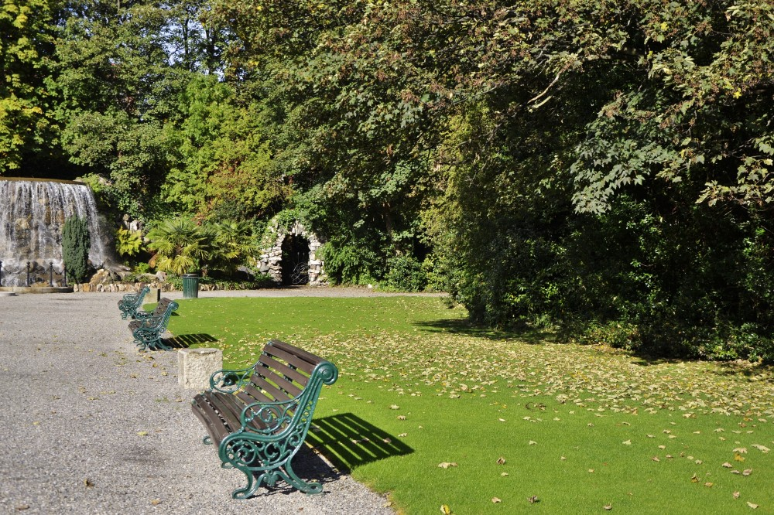
2. Mes sœurs __________________________________________________________

(marcher) _______________________________________________________

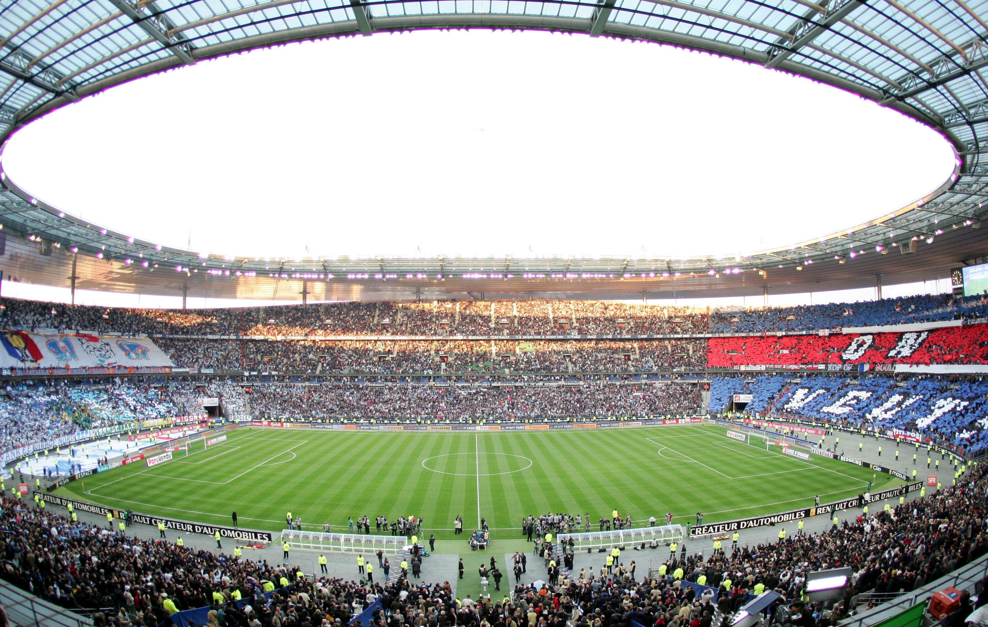
3. Jean-Luc et Thierry ____________________________________________________

(jouer) ____________________________________________________

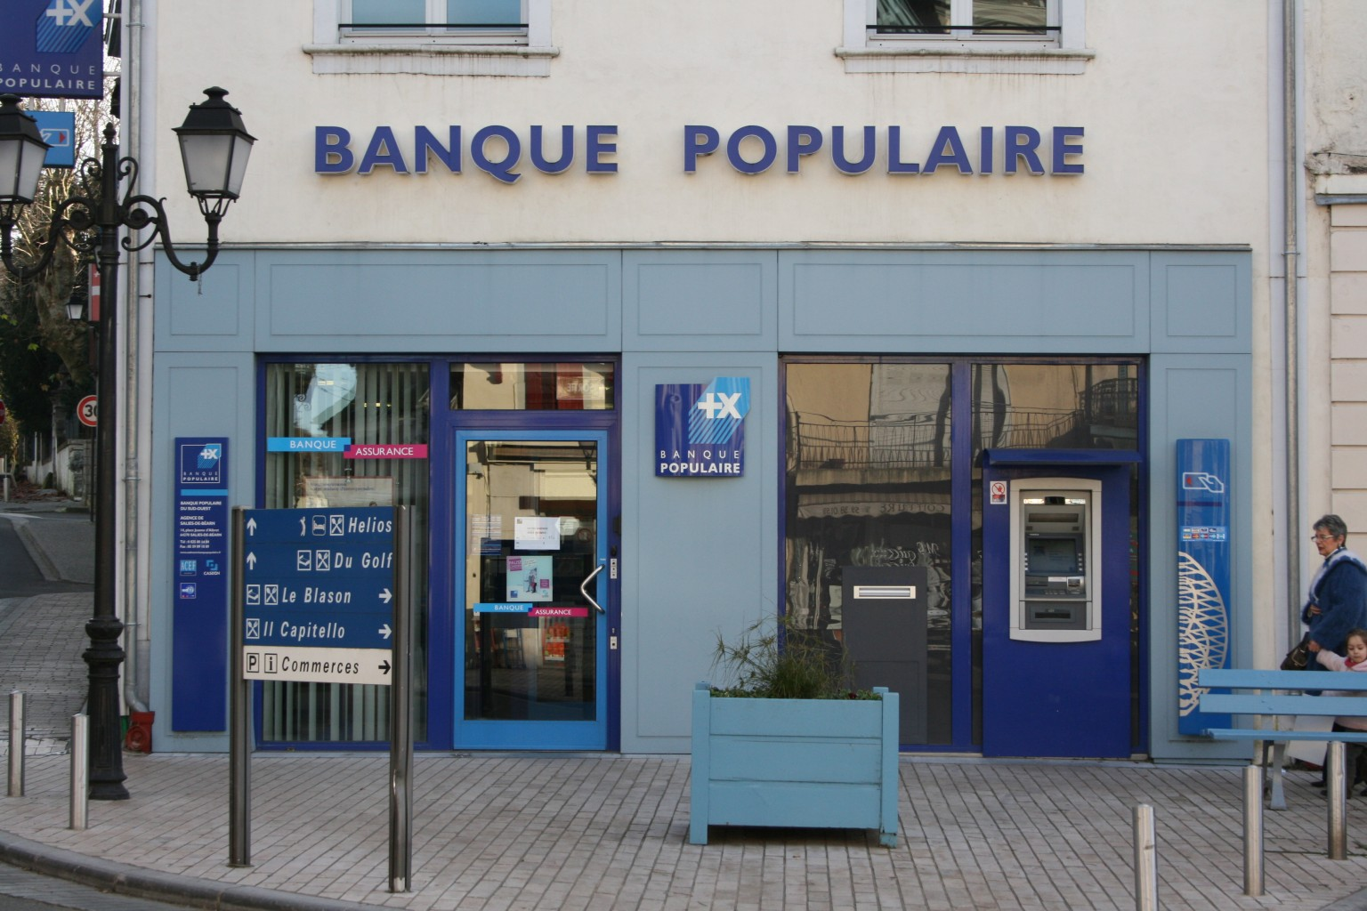
4. Ma famille _________________________________________________________

(acheter) _________________________________________________________

5. Vous _________________________________________________________________

(visiter) _________________________________________________________________

C. Describe what the following people did NOT do last weekend.

1. (acheter) Mélanie ___________________________________________ des fruits.

2. (faire) Hélène et Julien ___________________________________________ une promenade.

3. (voir) Nous ___________________________________________ des lions dans le parc!

4. (avoir) Mon frère ___________________________________________ un accident.

5. (prendre) Vous ___________________________________________ un bon repas au café.

D. Write 5 sentences telling what chores you did and did not do last weekend.

- ___________________________________________________________________________________
- ____________________________________________________________________________________
- ____________________________________________________________________________________
- ____________________________________________________________________________________
- ____________________________________________________________________________________
E. Les Fautes: First underline or circle the errors in the following paragraph. Then correct them. (Hint: Pay attention to the past tense.)

L’année dernière, je visité Disneyland avec ma famille. Nous avez vu Mickey Mouse ! Ma famille ont mangé à beaucoup de restaurants et nous dormi dans un hôtel. J’ai vole dans un avion pour arriver.

In Class Reflection:
Standard | 1  Below Level  (I don’t get it YET) | 2  Nearing Level  (I’m still working on it) | 3  At Level  (I’ve got it!) | 4  Above Level  (I can teach someone else) | My  Next Step  (What will I do outside of class to improve my proficiency in this standard?)
I can use the passé compose with avoir to write about past events.

