F3 Leçon 1.1.5 Nom ___________________________________
A. La pratique de vocabulaire : Practice the vocab for 10 minutes on this Quizlet: https://quizlet.com/_6wbxgp. Write down 6 new words you feel you have memorized. Don’t forget the article.
__________________________ ______________________________ ________________________
__________________________ ______________________________ ________________________

B. Le Vocabulaire: Match the following remedies to the symptoms given:

1- de la pommade  2- des béquilles  3- des comprimés  4- un pansement  5- une opération | - je me coupe le doigt  - ils ont l’appendicite  - vous avez une bosse  - tu as mal à la tête  - il se casse la cheville

C. Les recommendations: Write the recommendations pictured here below using a different expression for each one:

- Il faut… * Tu as besoin de/d’
- Tu dois...
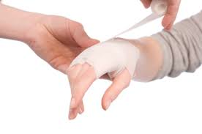

________________ ___________________ __________________ ________________ _______________

D. Les recommendations: For the following pictures, give two instructions on how to take care of the problem. Use a different expression for each picture:

- Il faut… tu as besoin de…
- Vous devez...
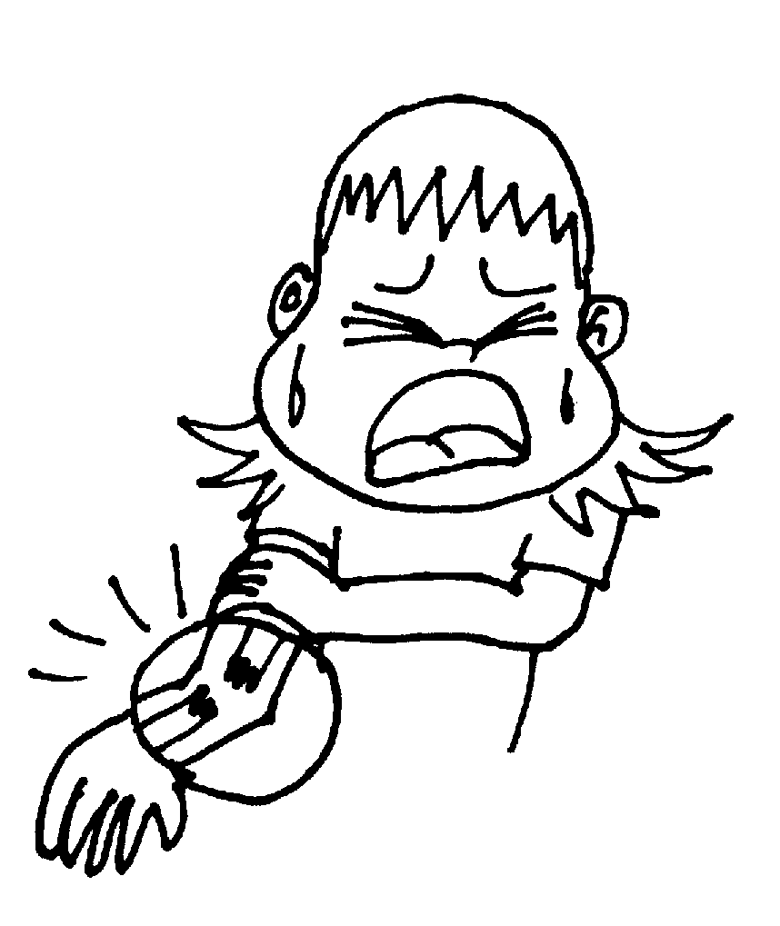

___________________________________ ___________________________________

___________________________________ ___________________________________

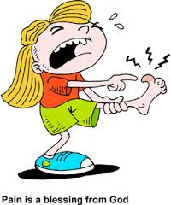

___________________________________ ___________________________________

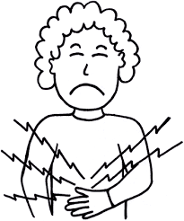

___________________________________ ___________________________________
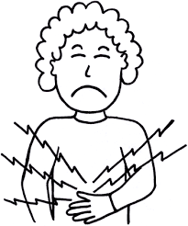
E. La santé : Imagine you are a doctor who receives an email from a patient describing the following problems:

- des courbatures au dos
- une migraine de 5 jours
- une otite
- une angine
- une grosse fatigue
Write the patient instructions on how to care for each problem.
Remember that our goal is intermediate mid.

NL  Novice Low | NM  Novice Mid | NH  Novice High | IL  Intermediate Low | IM  Intermediate Mid | IH  Intermediate High
words | memorized phrases, simple sentences | some sentences, elaborates a little | strings of sentences, more elaboration | connected sentences, better quality and quantity, questions | well-connected sentences, almost paragraphs, questions

____________________________________________________________________________________________________________________________________________________________________________________
______________________________________________________________________________________________________________________________________________________________________________________________________________________________________________________________________________
____________________________________________________________________________________________________________________________________________________________________________________
____________________________________________________________________________________________________________________________________________________________________________________
In Class Reflection:
Standard | 1  Below Level  (I don’t get it YET) | 2  Nearing Level  (I’m still working on it) | 3  At Level  (I’ve got it!) | 4  Above Level  (I can teach someone else) | My Next Step  (What will I do outside of class to improve my proficiency in this standard?)
I can use the vocabulary to talk about symptoms.
I can give recommendations using a variety of expressions.
I can write about health at an intermediate mid level.

