F3 Leçon 1.1 Devoirs 1 Nom ______________________________

A. La pratique de vocabulaire: Practice the vocab for 10 minutes on Quizlet using this url: https://quizlet.com/_6wpvpq. Write down 5 new words you feel you have memorized. Don’t forget the article.

1. _________________________

2. _________________________

3. _________________________

4. _________________________

5. _________________________

B. La pratique écrite : Comment se sentent-ils? Write how the following people are feeling and the symptoms if shown.

_____________________________ _____________________
_____________________________ _______________________

______________________________ _____________________

C. Label the following parts of the body! Include le, la, l’, or les.

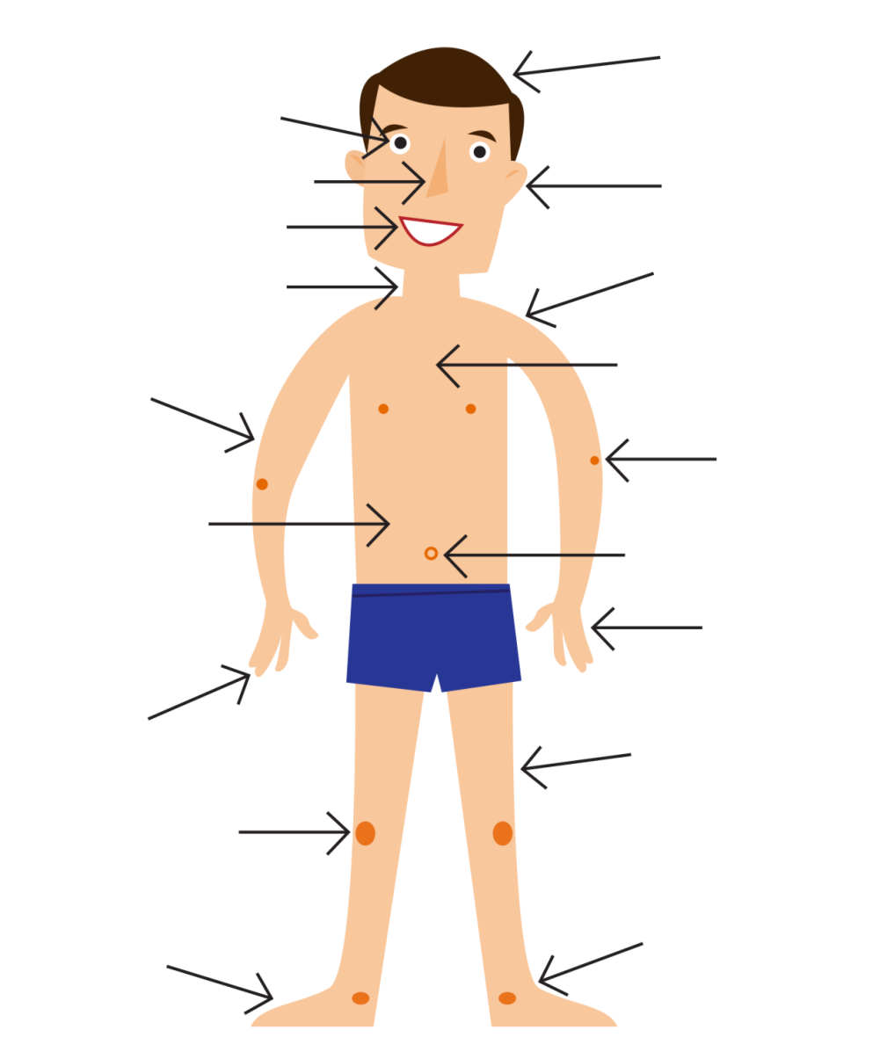

In Class Reflection:
Standard | 1  Below Level  (I don’t get it YET) | 2  Nearing Level  (I’m still working on it) | 3  At Level  (I’ve got it!) | 4  Above Level  (I can teach someone else) | My Next Step  (What will I do outside of class to improve my proficiency in this standard?)
I can use the vocabulary to talk about how I feel.

